Project Design Phase-II
Technology Stack (Architecture & Stack)

Date | 30 September 2026
Team ID | 6abab772b81abcc53b06d3f7
Project Name | Import Data using Transform Maps (Spreadsheet)
Maximum Marks | 4 Marks

1. System Architecture Diagram Description & Flow
Below is the structured architectural sequence adhering to enterprise guidelines:
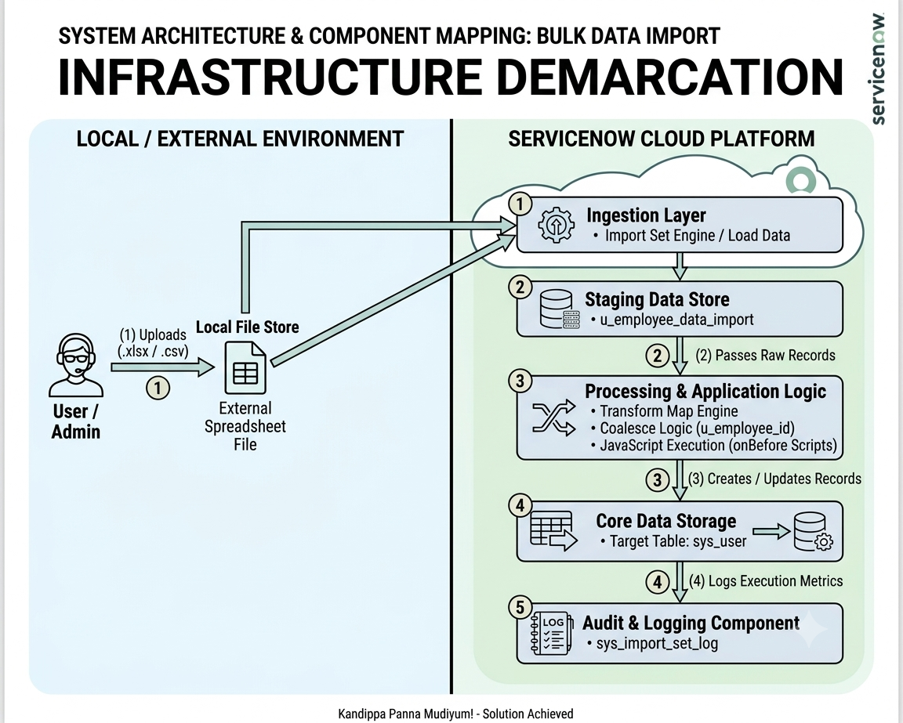

Table 1: System Components & Architectural Blocks
Component Name | Architectural Block Type | Infrastructure Location | Description & Functionality
Excel Spreadsheet (.xlsx) | External Data Source / Interface | Local / External System | Stores raw employee data files received from HR/External systems before ingestion.
Load Data Module | Application Ingestion Interface | ServiceNow Cloud | ServiceNow native interface that accepts flat files and builds temporary schema structures.
Staging Table (u_employee_data_import) | Data Storage (Temporary Buffer) | ServiceNow Cloud | Staging table extending sys_import_set_row that isolates raw data from production tables.
Transform Map Engine | Application Logic / Processing | ServiceNow Cloud | Maps source staging columns to destination target fields using structural schema rules.
Coalesce Engine | Business Logic / Deduplication | ServiceNow Cloud | Evaluates unique primary key matches (u_employee_id $→$ user_name) to execute Upsert actions.
onBefore Script Layer | Application Logic (Custom Script) | ServiceNow Cloud | JavaScript execution block performing string trimming, lowercasing, and conditional row filtering.
Target User Table (sys_user) | Data Storage (Core Operational) | ServiceNow Cloud | Production database table housing validated employee profiles and platform identity data.
Import Set Log (sys_import_set_log) | Audit & Monitoring Block | ServiceNow Cloud | Audit component logging total execution metrics (Inserts, Updates, Ignored, and Errors).

Table 2: External Interfaces & Data Flow Mapping
Step # | Source Component | Target Component | Protocol / Interface Type | Data Transferred
1 | External Admin / User | Load Data Module | HTTPS / Web GUI Upload | Raw Microsoft Excel Spreadsheet file (.xlsx).
2 | Load Data Module | Staging Table (u_employee_data_import) | Internal Platform Ingestion | Parsed spreadsheet rows mapped into temporary database columns.
3 | Staging Table | Transform Map Engine | Internal Data Stream | Raw string records fetched row-by-row for processing.
4 | Transform Map Engine | Coalesce Engine | Application Logic Lookup | Query against sys_user using u_employee_id key.
5 | onBefore Script Layer | Target Table (sys_user) | Direct DB Insert / Update | Cleaned employee data (Name, Email, Department, Title, Active Status).
6 | Transform Map Engine | Audit Log (sys_import_set_log) | Transaction Logging | Execution summary counts (Inserts, Updates, Errors, Completion Status).

